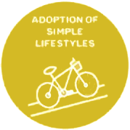
Goal 4
ADOPTION OF SIMPLE LIFESTYLES

GOAL: Adoption of Simple Lifestyles is grounded in the idea of sufficiency, and promoting sobriety (moderation) in the use of resources and energy.

STRATEGY 1:
Decrease water consumption where we live and work.

ACTIONS:
- Track water usage through the monthly water bill.

- Determine water and energy efficiency of all home appliances, showers, and outdoor sprinklers.

- Have regular conversations where we live and work about conservation of water practices.

- Collect excess water in basins to water plants and garden.

- Collaborate with gardeners for sustainable gardening practices and use of water, including the planting of drought-resistant trees and plants.

- Take personal responsibility to decrease water usage in daily personal hygiene, kitchen and laundry.

STRATEGY 2:
Moderation concerning the use of water resources.

ACTIONS:
- Conserve water by taking fewer or shorter showers; turning off water while washing hands and brushing teeth; using dishwasher as necessary and only when full; doing full loads of laundry.

- Eliminate the use of bottled water by using filtered tap water for drinking, washing fruits and vegetables and cooking, as well as promoting good health.

