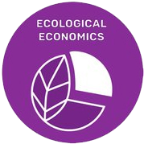
Goal 3
ECOLOGICAL ECONOMICS

GOAL:

Ecological Economics acknowledges that the economy is a sub-system of human society, which itself is embedded within the biosphere–our common home.

STRATEGY 1:
Socially responsible investing (SRI) as an on-going reality.

ACTIONS:
- Continue to invest with Christian Brothers Investment Services (CBIS) faithful to the moral and Social Teachings of the Catholic Church.
- Invest in eco-friendly “green” corporations/companies that demonstrate a commitment to an environmentally sustainable future.
- Invest in corporations/companies that can be influenced to create and maintain sustainable water practices.

STRATEGY 2:
Allocation of funds for water and energy saving appliances.

ACTIONS:
- Evaluate existing appliances for water and energy consumption.
- Replace appliances as needed to reduce water and energy consumption.
- Monitor monthly water and energy usage to determine consumption level.

STRATEGY 3:
Allocation of funds for adequate water filters for health benefits.

ACTIONS:
- Evaluate existing water filtering systems for water quality.
- Install or replace adequate filtering systems as needed to promote good health.

